1. Provide a screenshot to show that you have successfully created the MBTANetwork network.

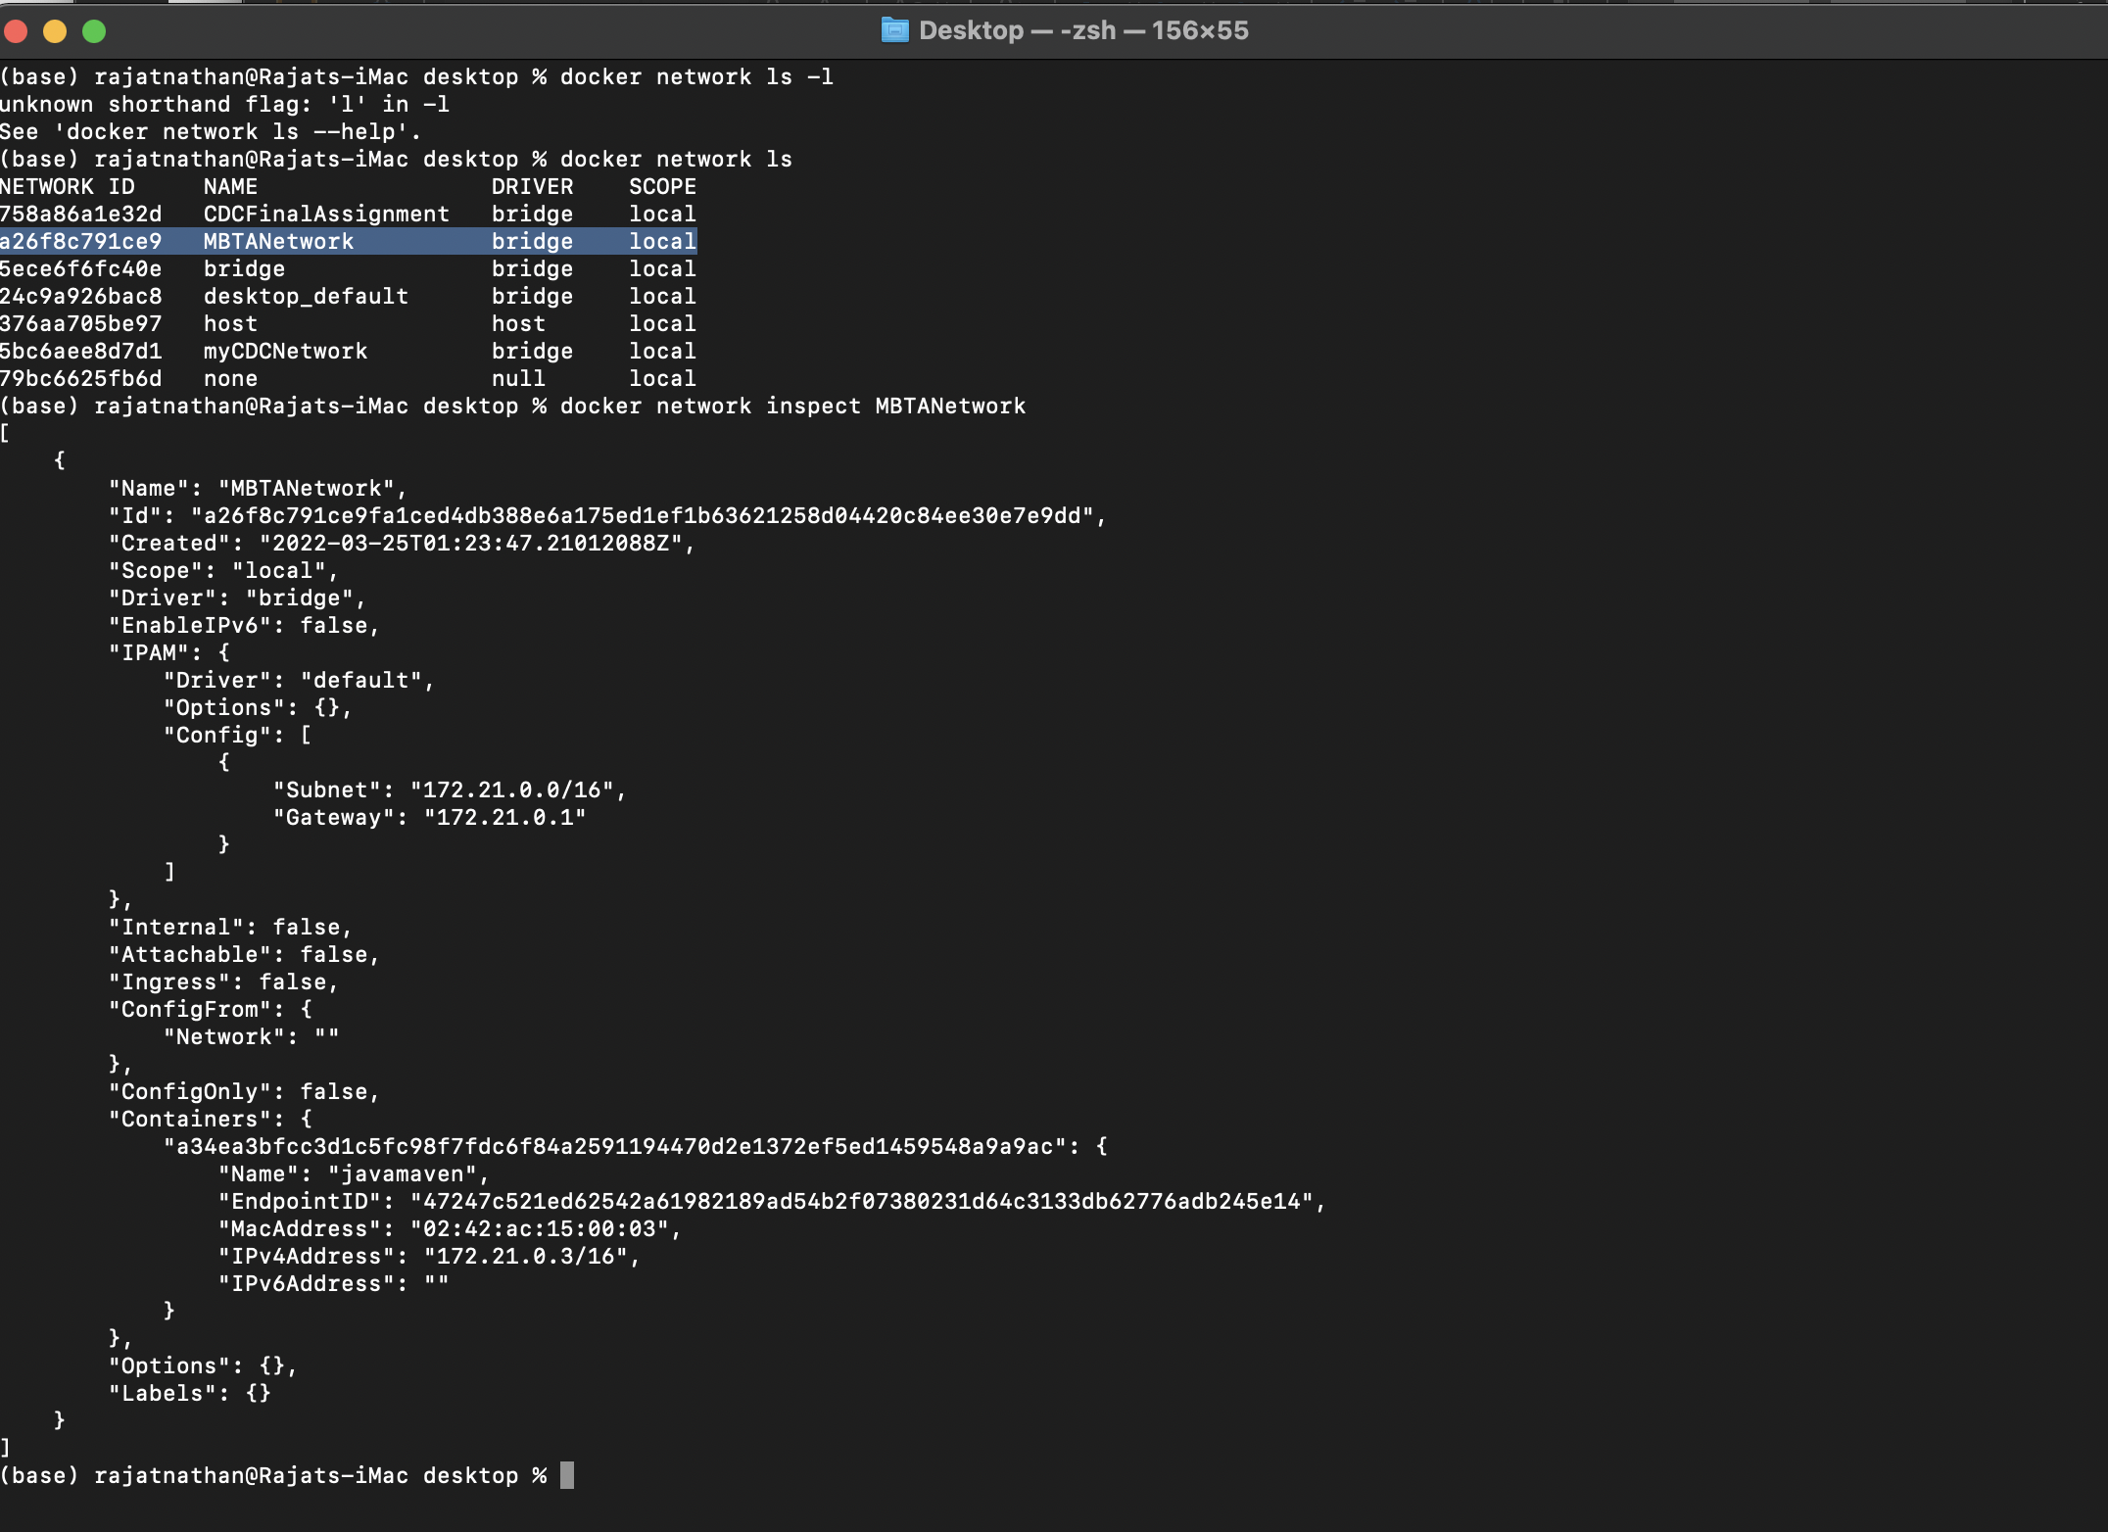

1. Provide a screenshot to show that you have successfully opened the mysqlDocker folder.

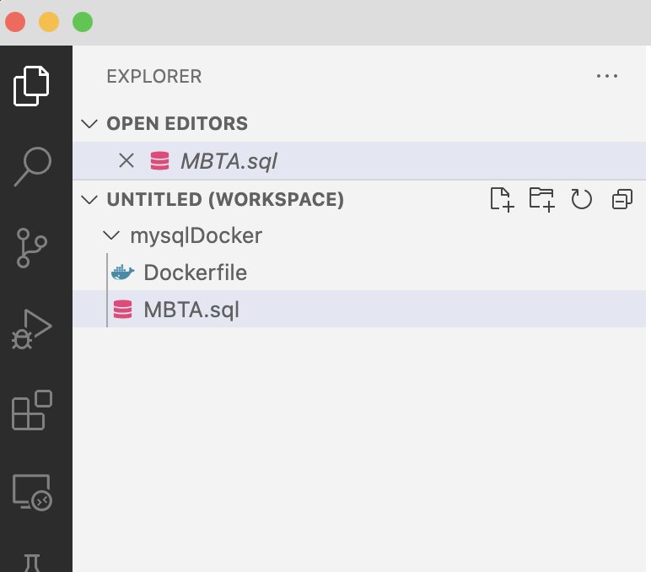

* 1. Provide a screenshot to show that you have successfully opened the MBTA.sql file.

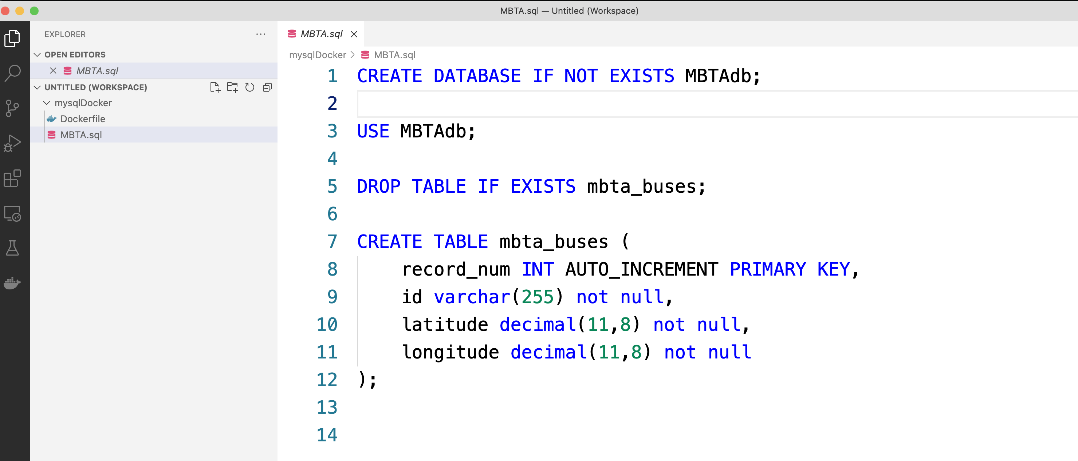

* 1. For this step, you will provide two screenshots. The first screenshot should show that you have successfully run the provided code in a Jupyter Notebook. The second screenshot should show that you have successfully added at least five additional fields to the mbta_buses table.

**Screenshot 1:**

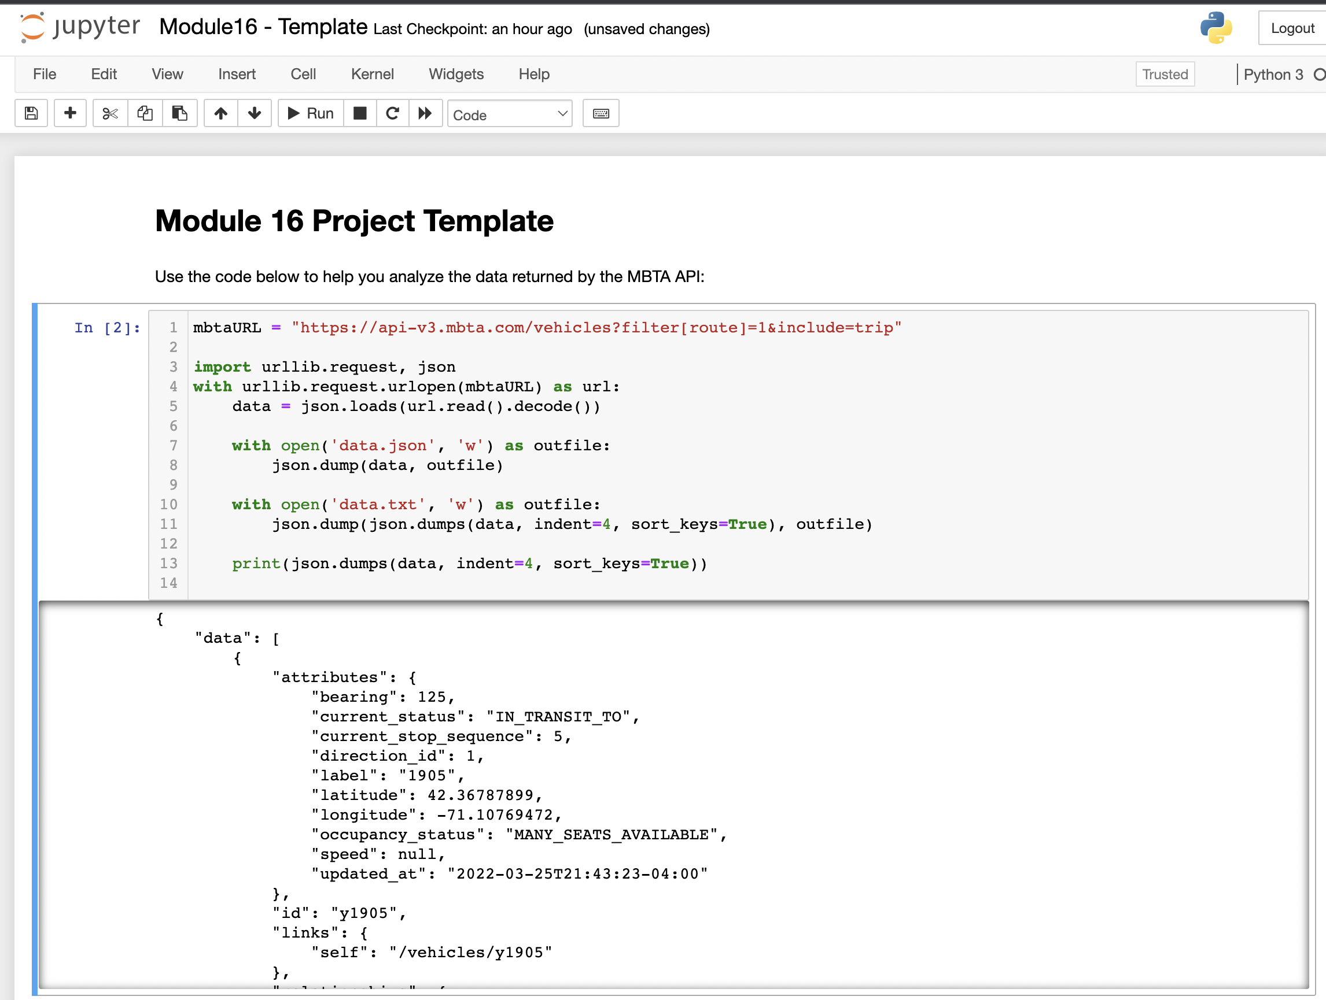

**Screenshot 2:**

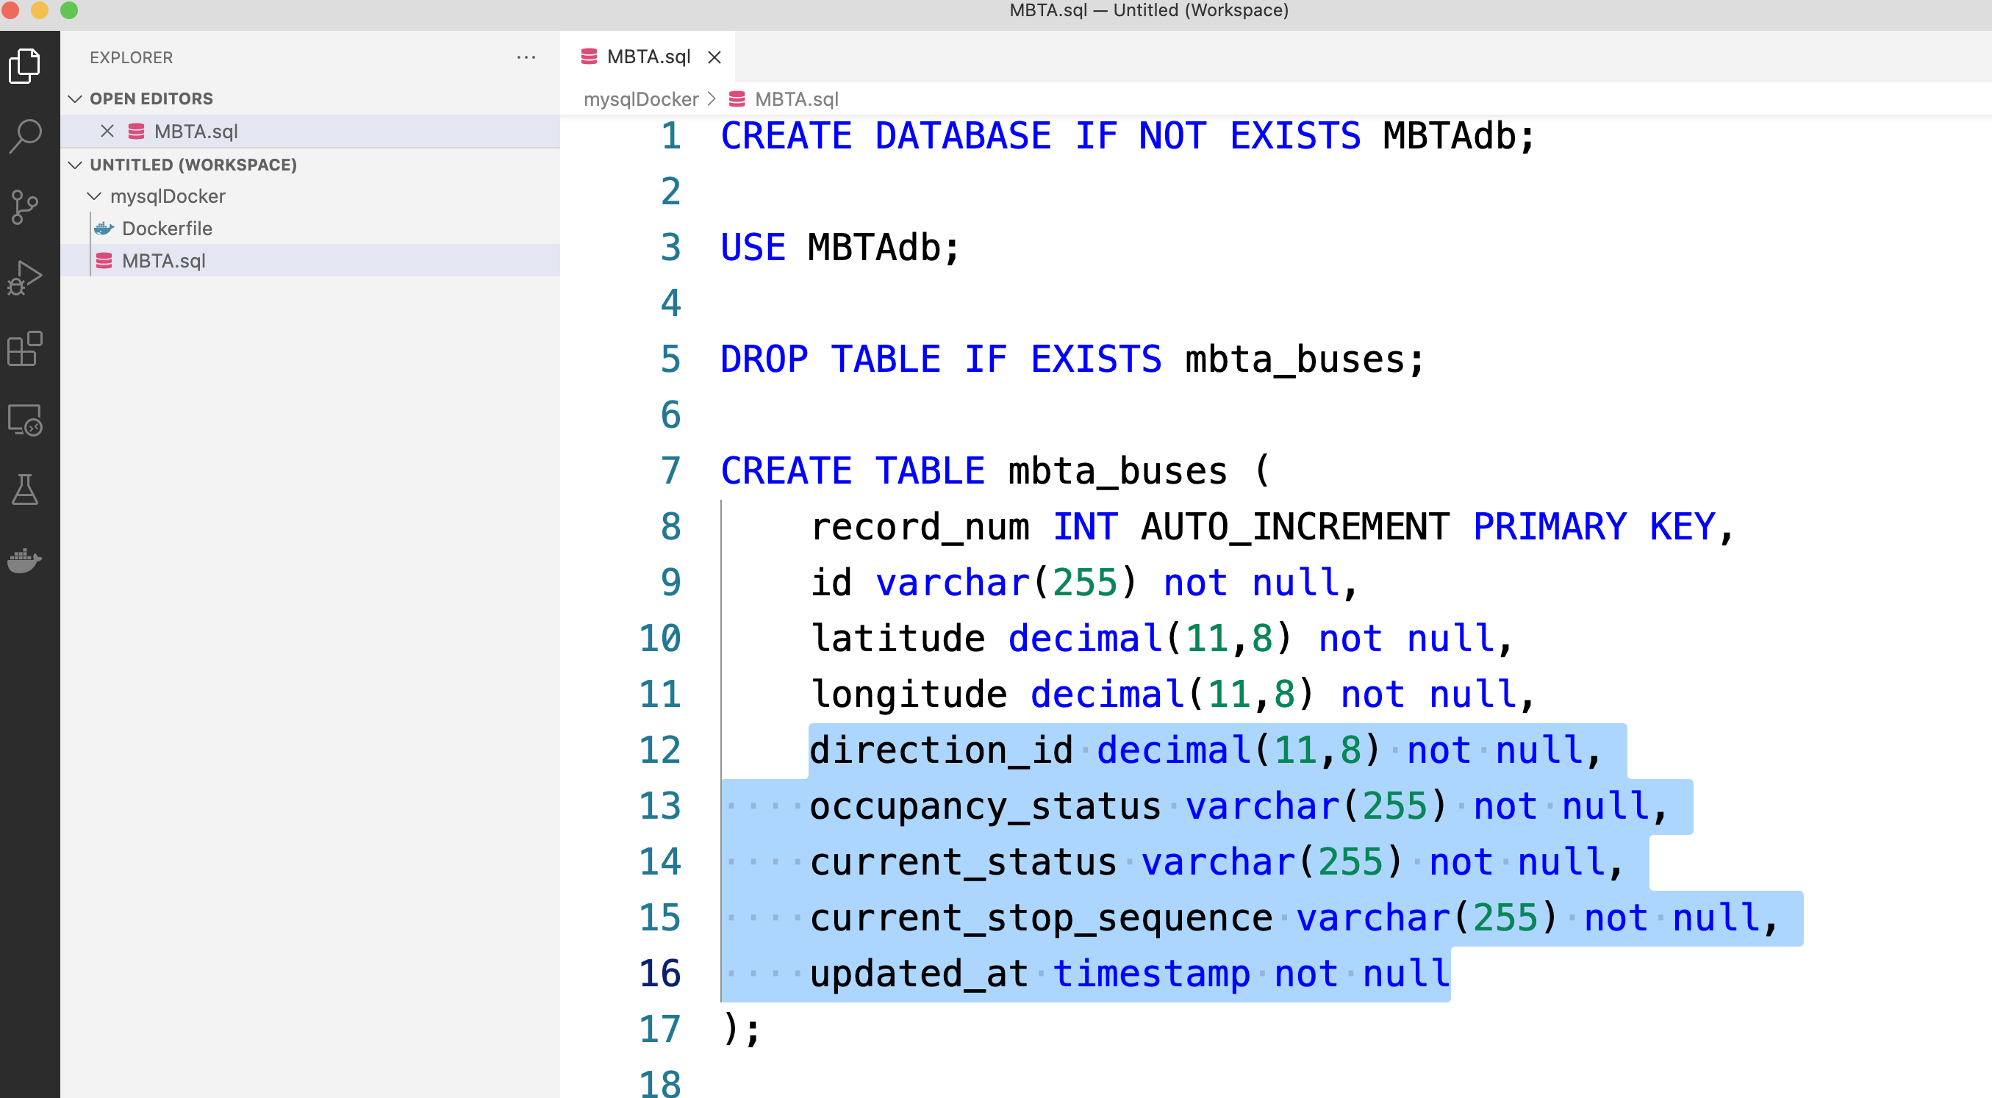

* 1. Provide a screenshot to show that you have successfully created the mysqlmbtamasterimg Docker *image*.

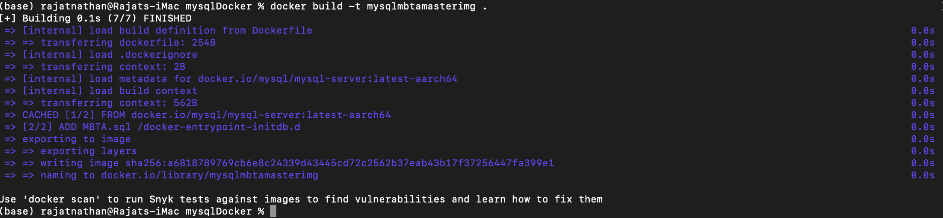

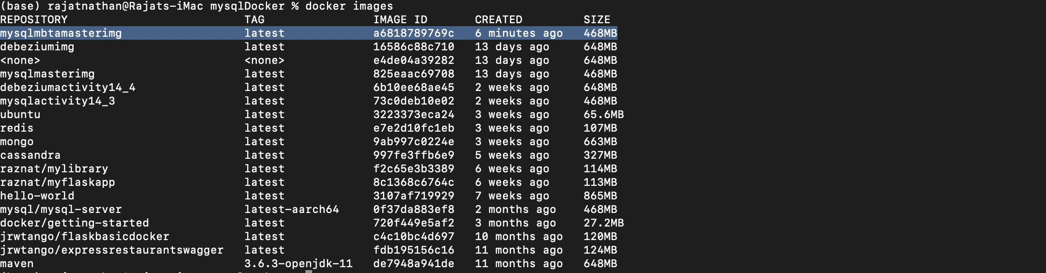

* 1. Provide a screenshot to show that you have successfully created the mysqlserver Docker *container*.



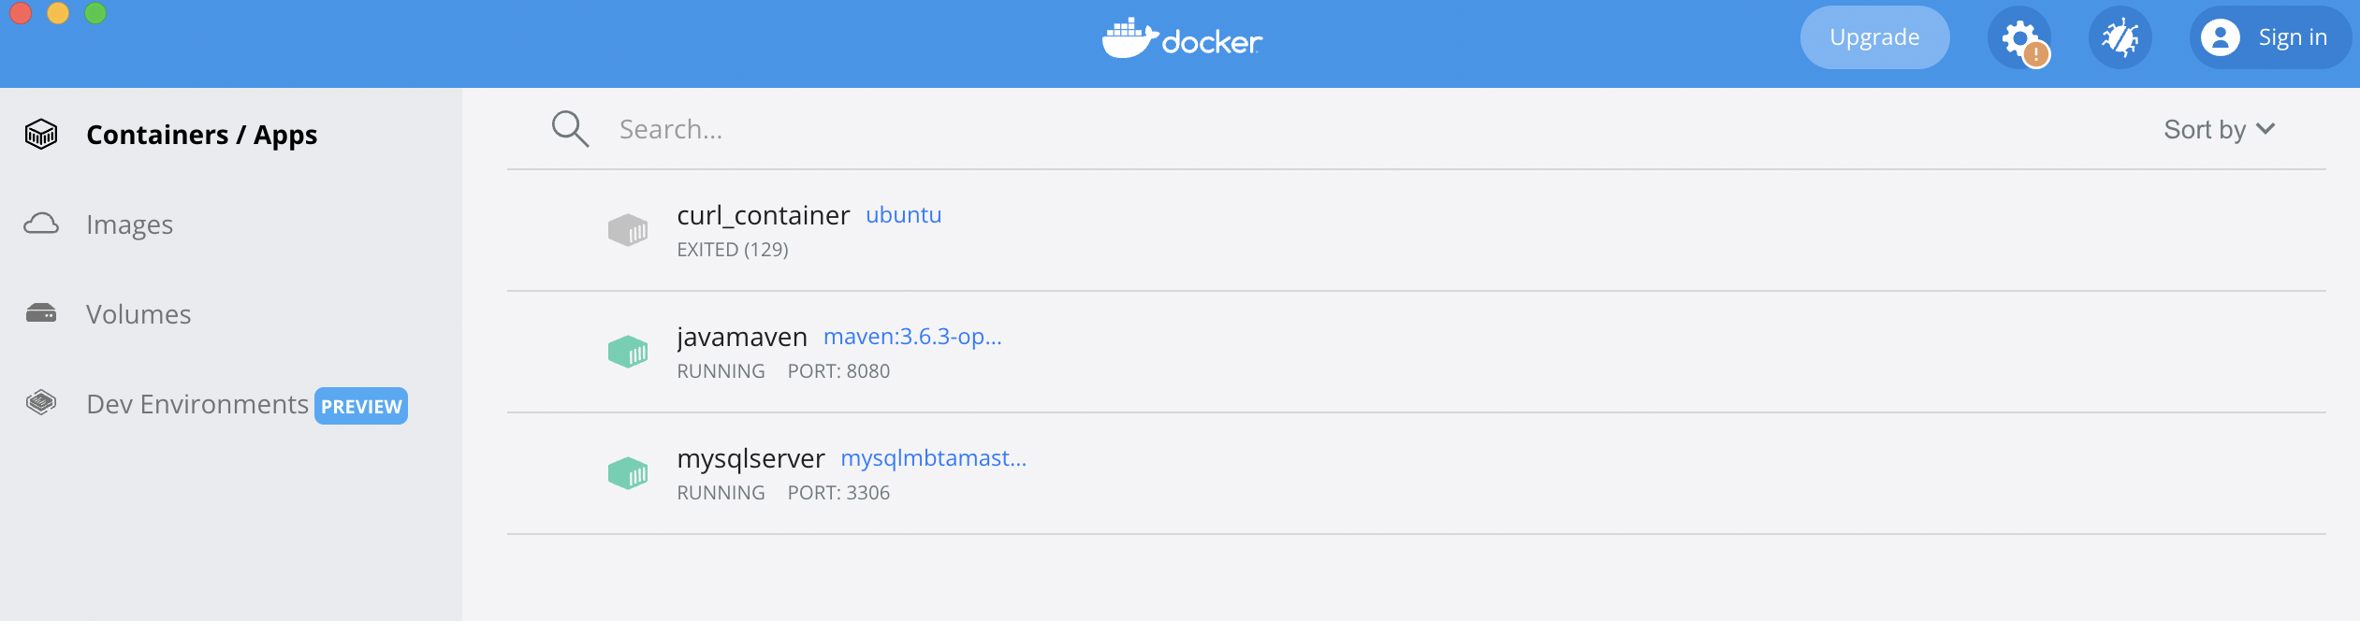

1. Provide a screenshot to show that you have successfully created the some-mongo Docker *container*.

Created some-mongo container

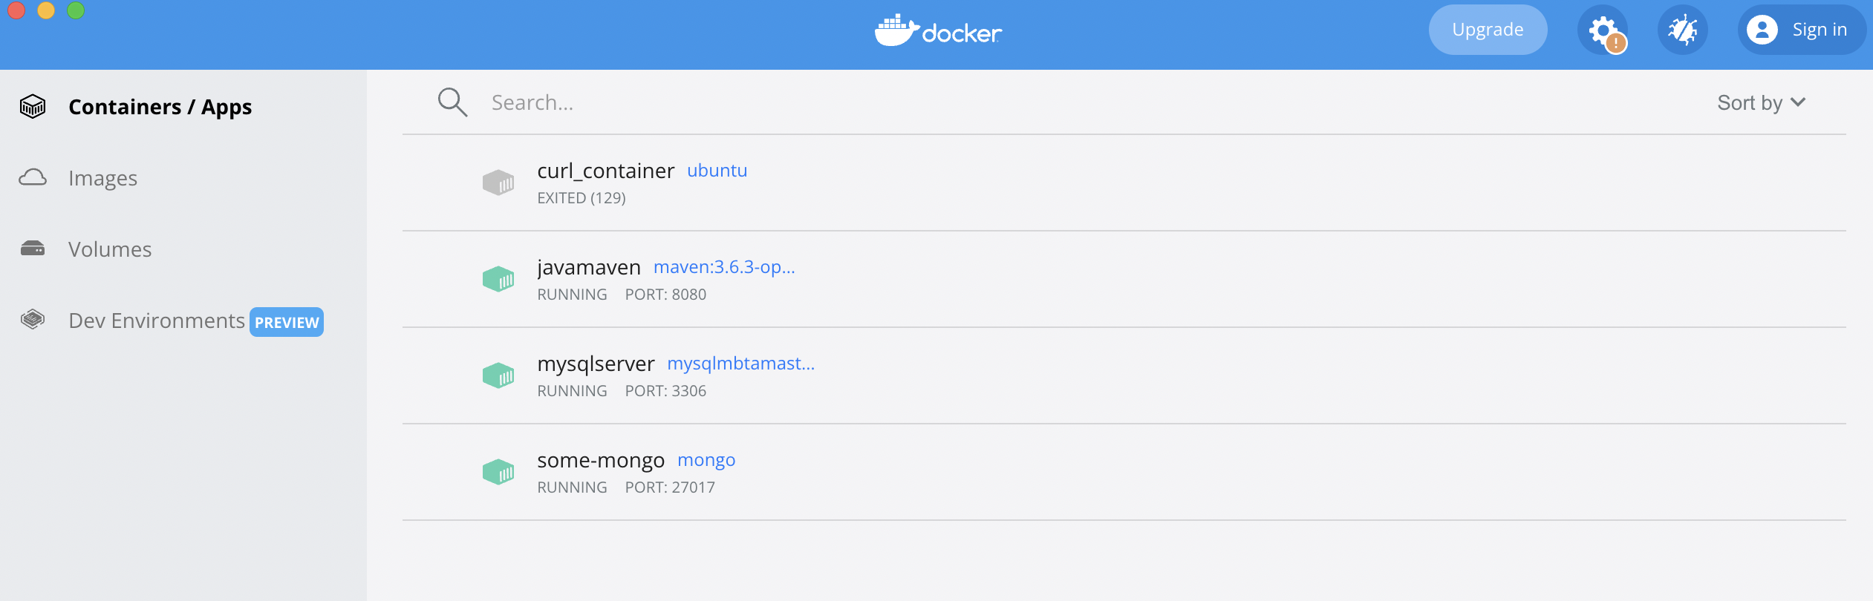

Adding ‘some-mongo’ container to MBTANetwork

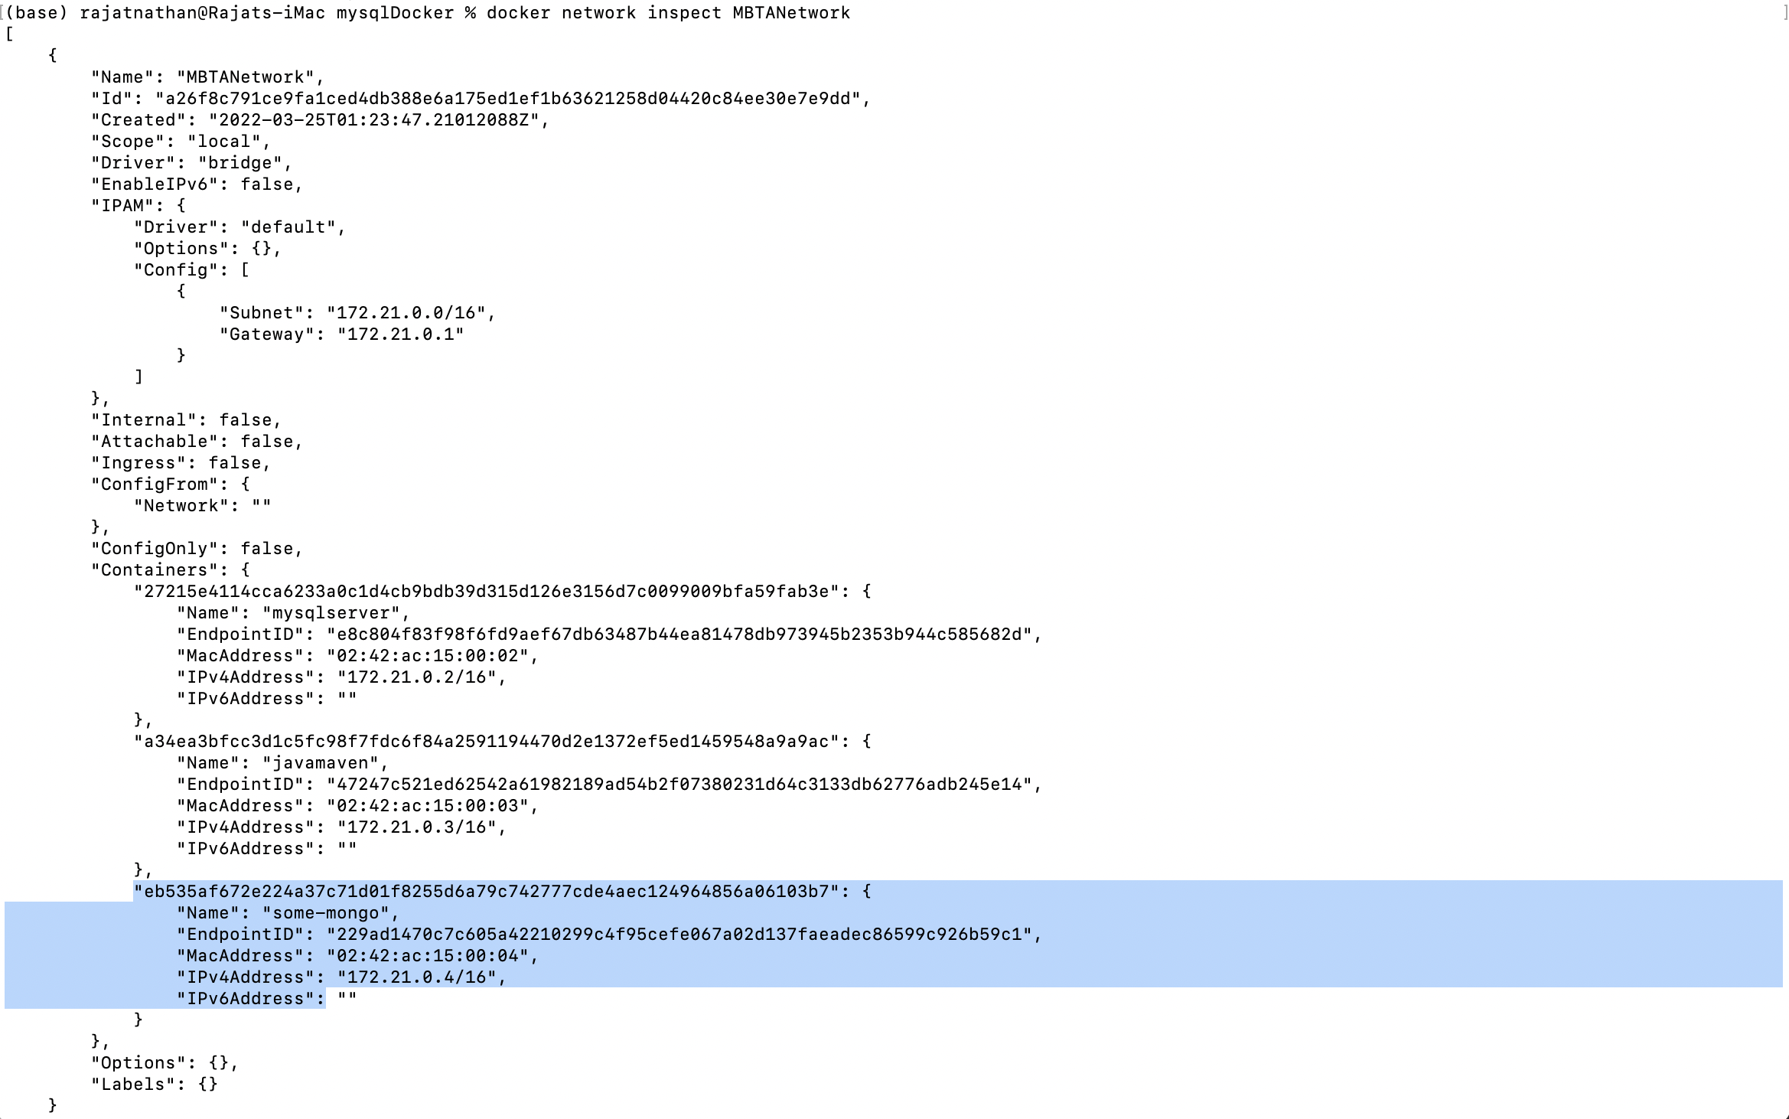

1. 1. Provide a screenshot to show that you have successfully opened the Module16ProjectFlask.zip folder in VS Code.

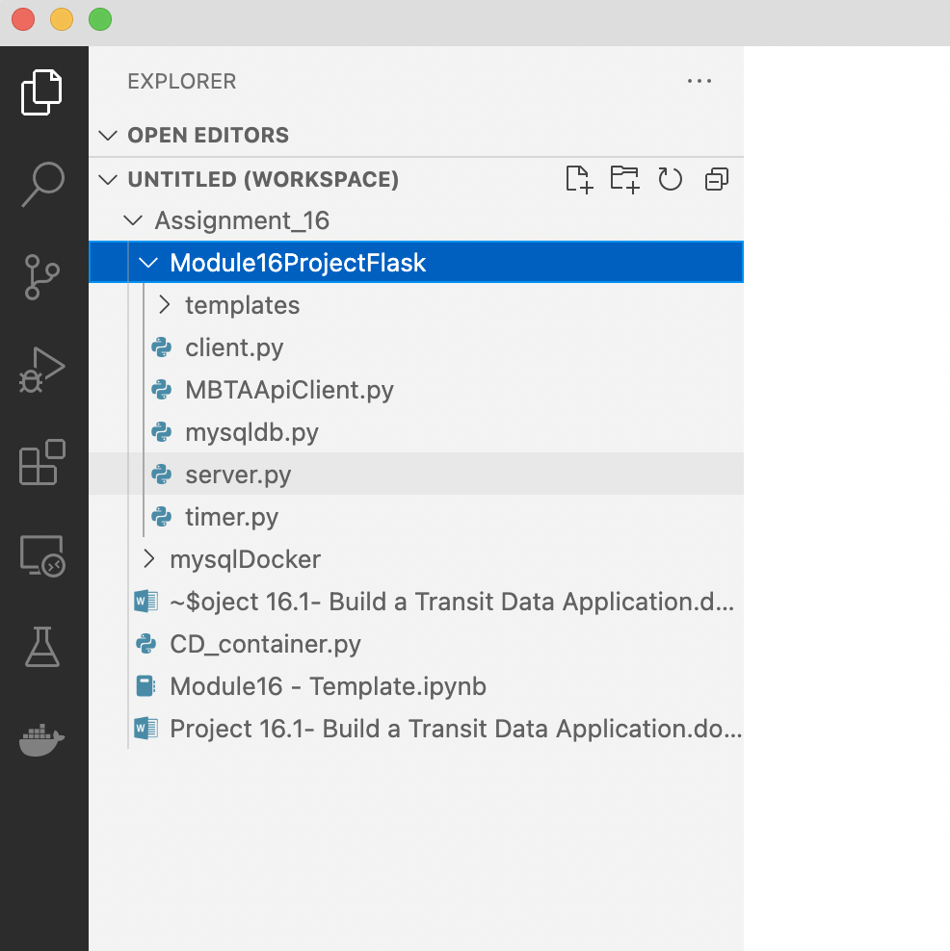

* 1. Provide a screenshot to show that you have successfully modified the mysqldb.py file.

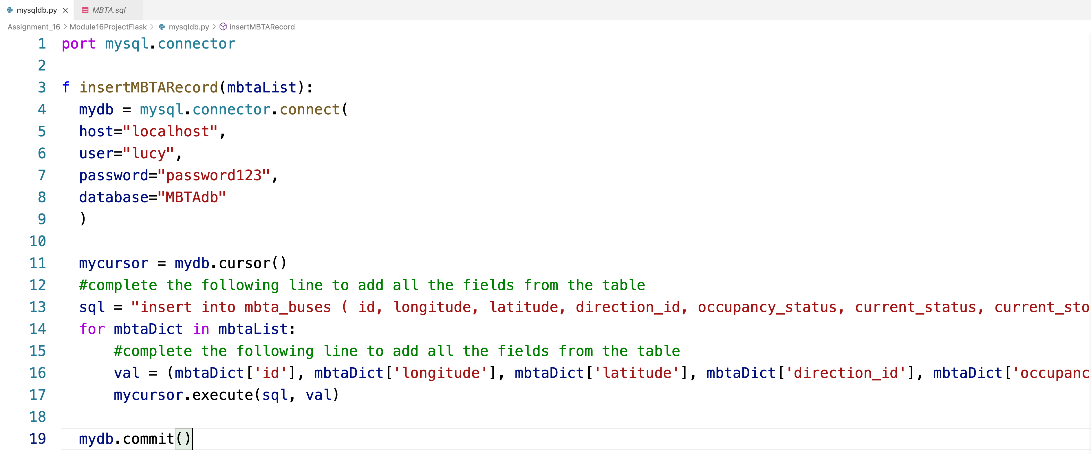

* 1. Provide a screenshot to show that you have successfully modified the MBTAApiClient.py file.

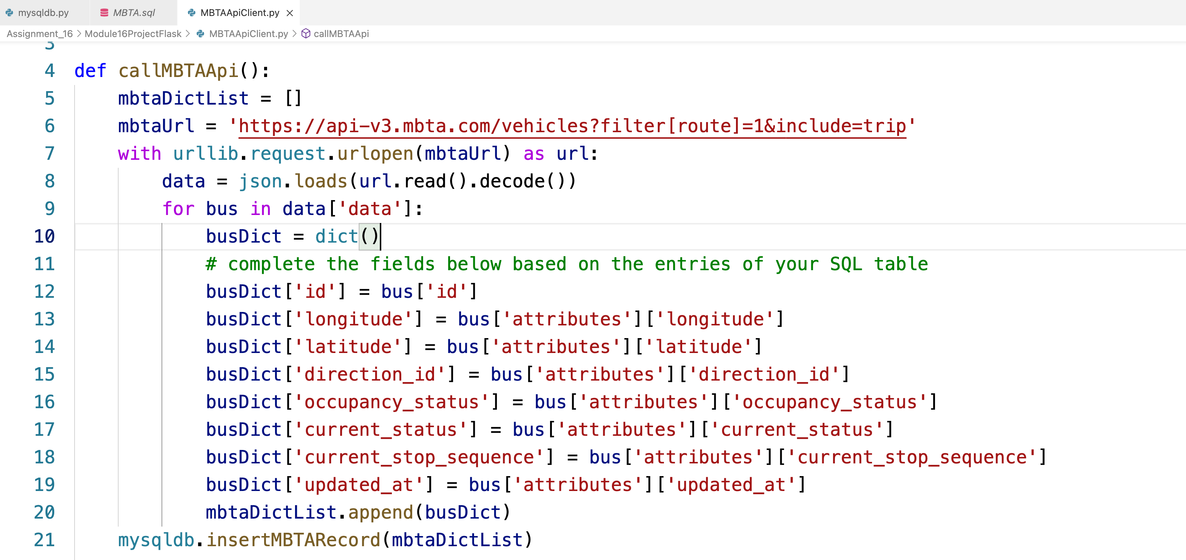

* 1. Provide a screenshot to show that you have successfully added your Mapbox access *token*in the index.htmlfile.

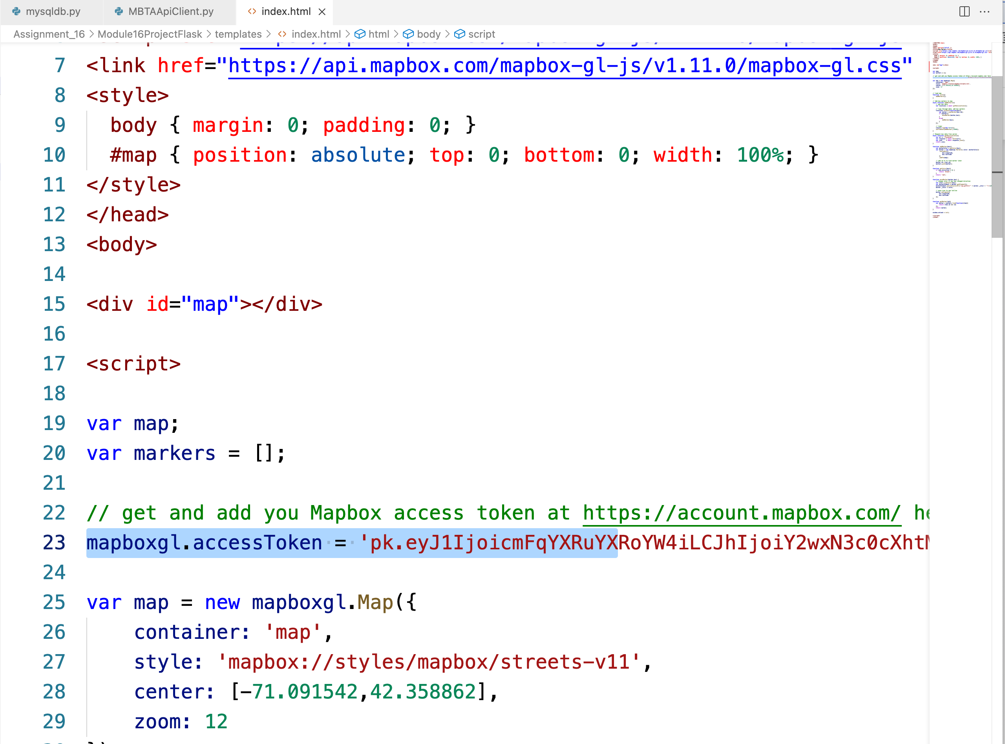

* 1. Provide a screenshot to show that you have successfully initialized the buses *list*in the server.py file.

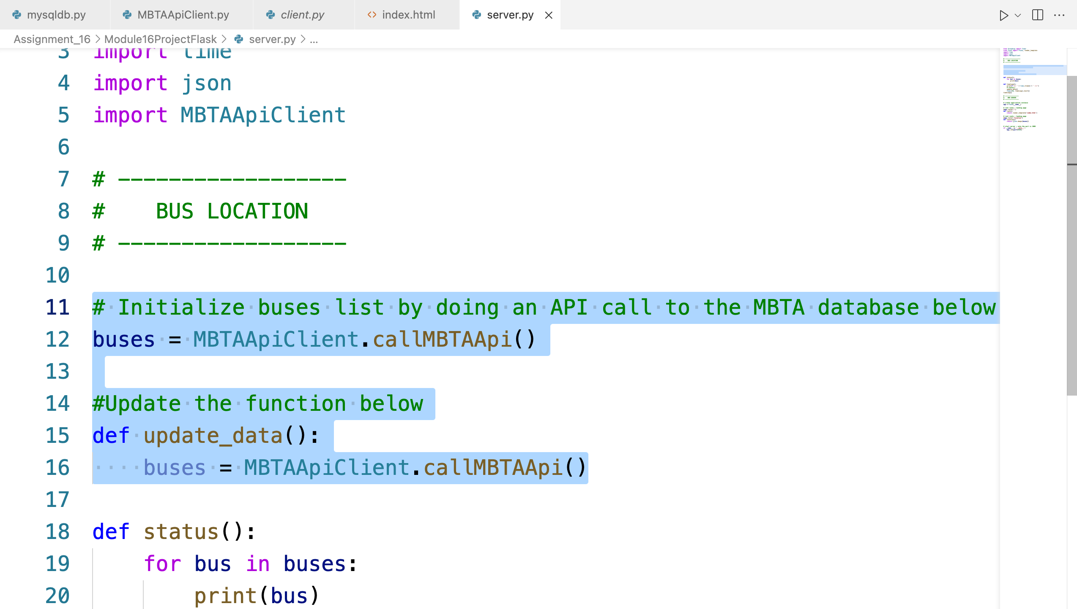

* 1. Provide a screenshot to show that you have successfully run the server.py file in VS Code.

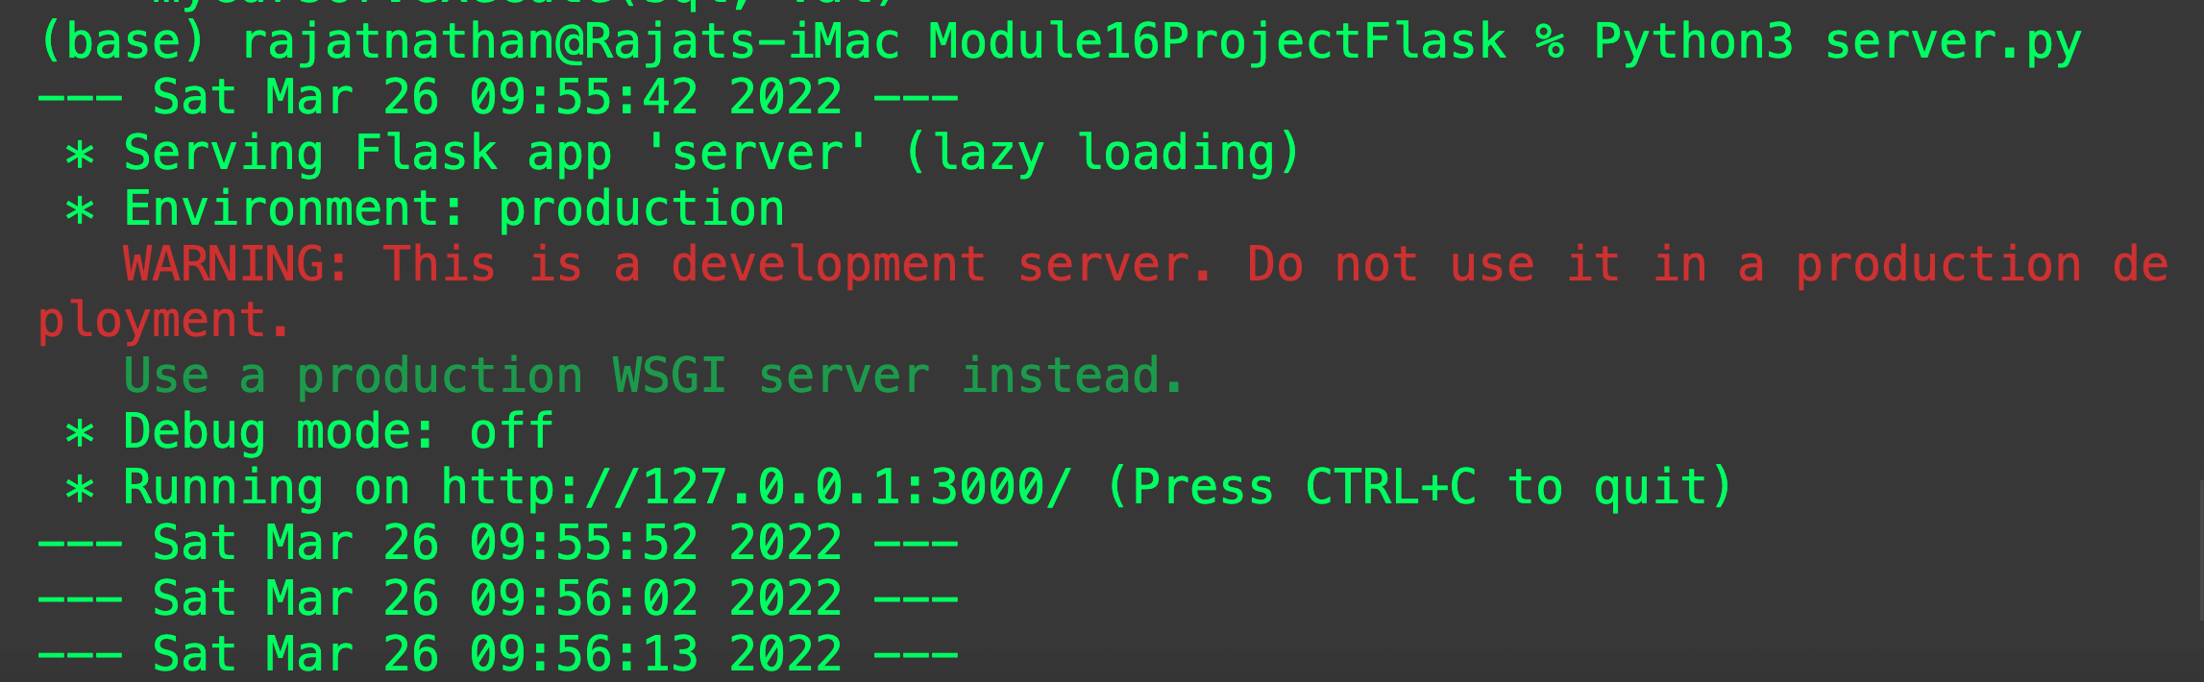

* 1. Provide a screenshot to show that you have successfully navigated to localhost:3000.

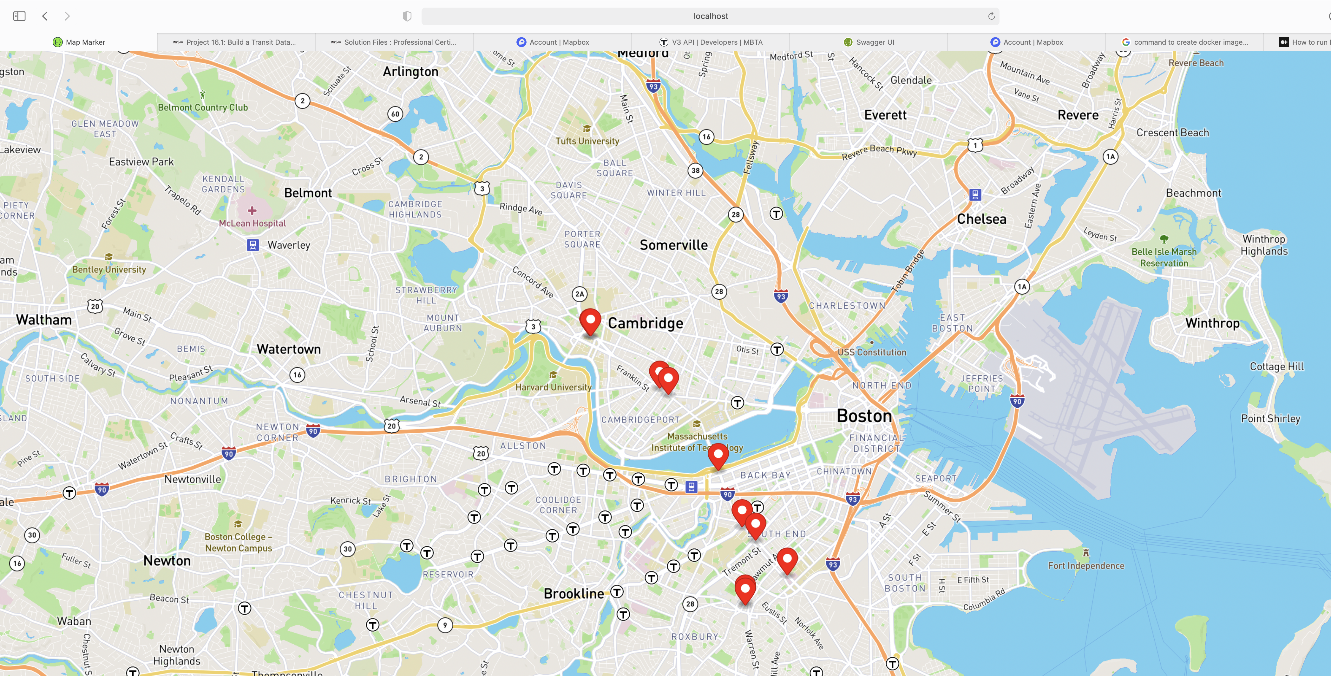

1. * 1. Provide a screenshot to show that you have successfully opened the DebeziumCDC.zip folder in VS Code.

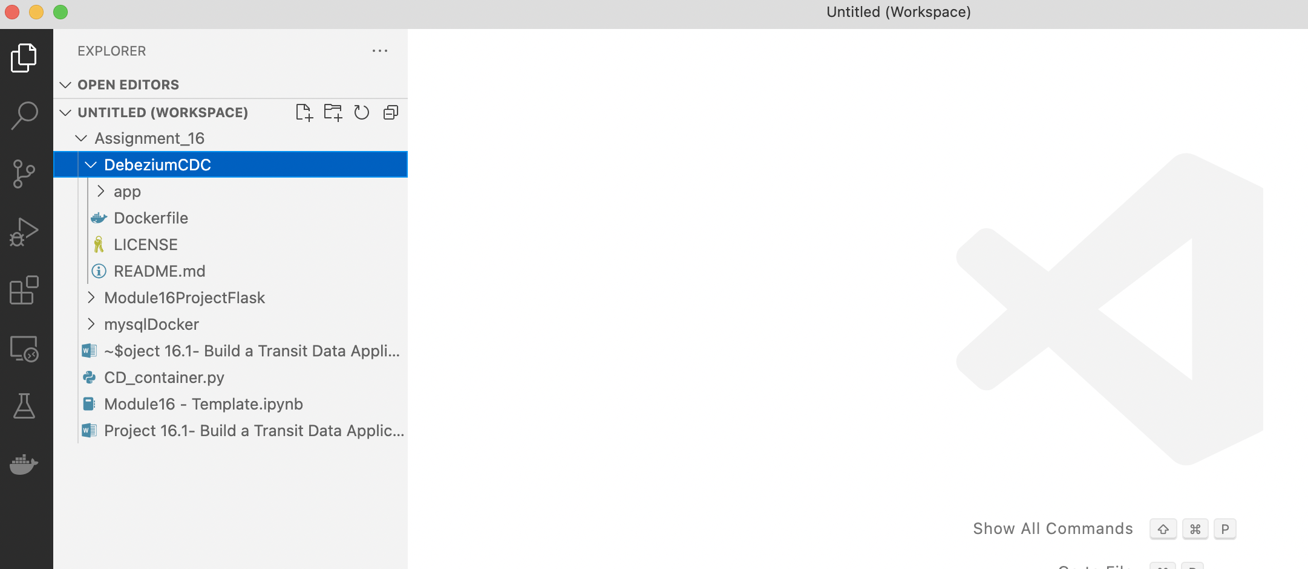

* + 1. Provide a screenshot to show that you have successfully created the debeziummodule16 Docker image.

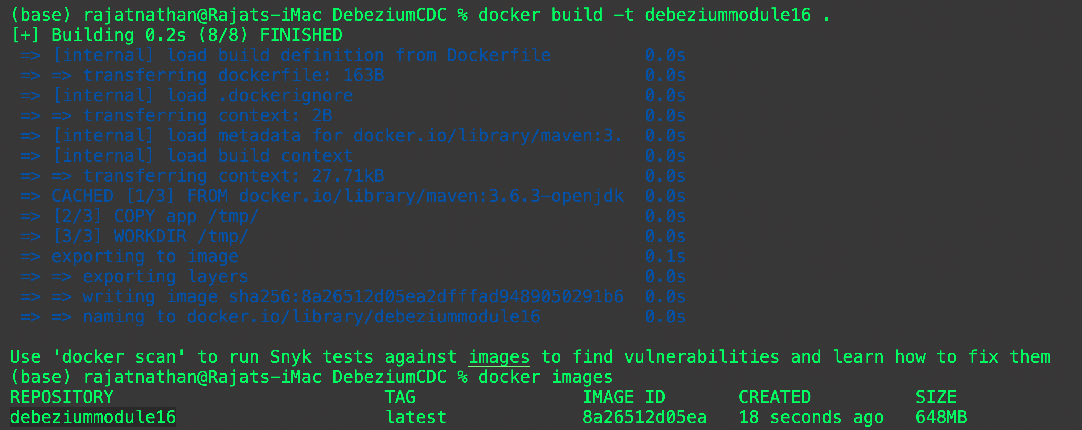

* + 1. Provide a screenshot to show that you have successfully created the Docker container and associated it with the MBTANetwork network.



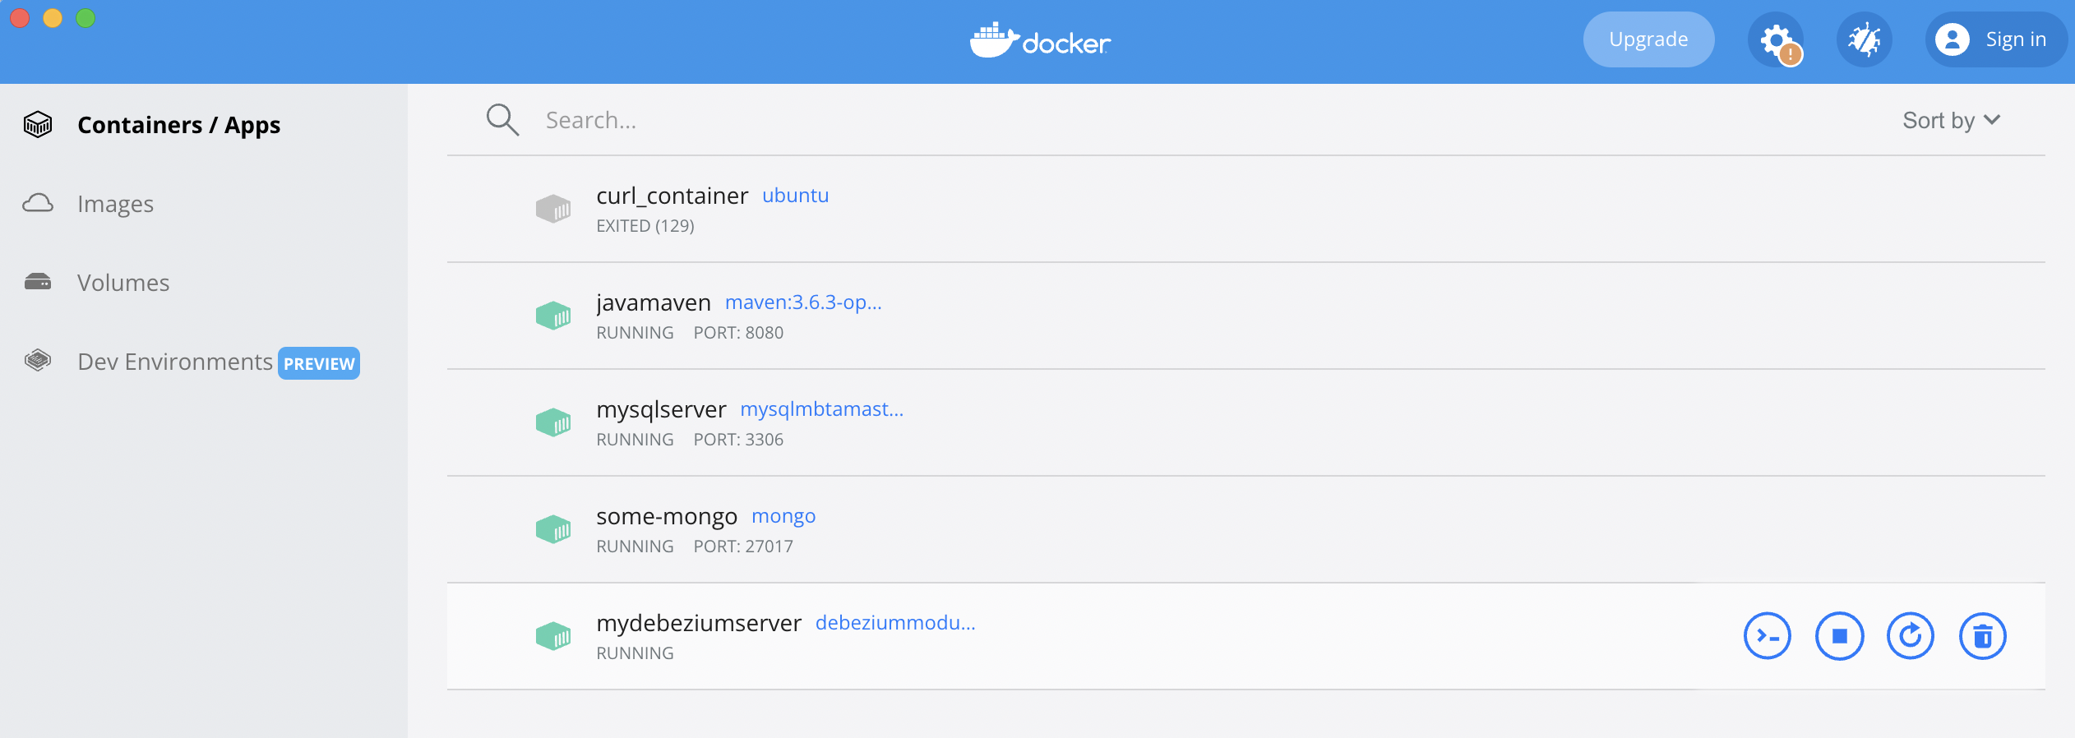

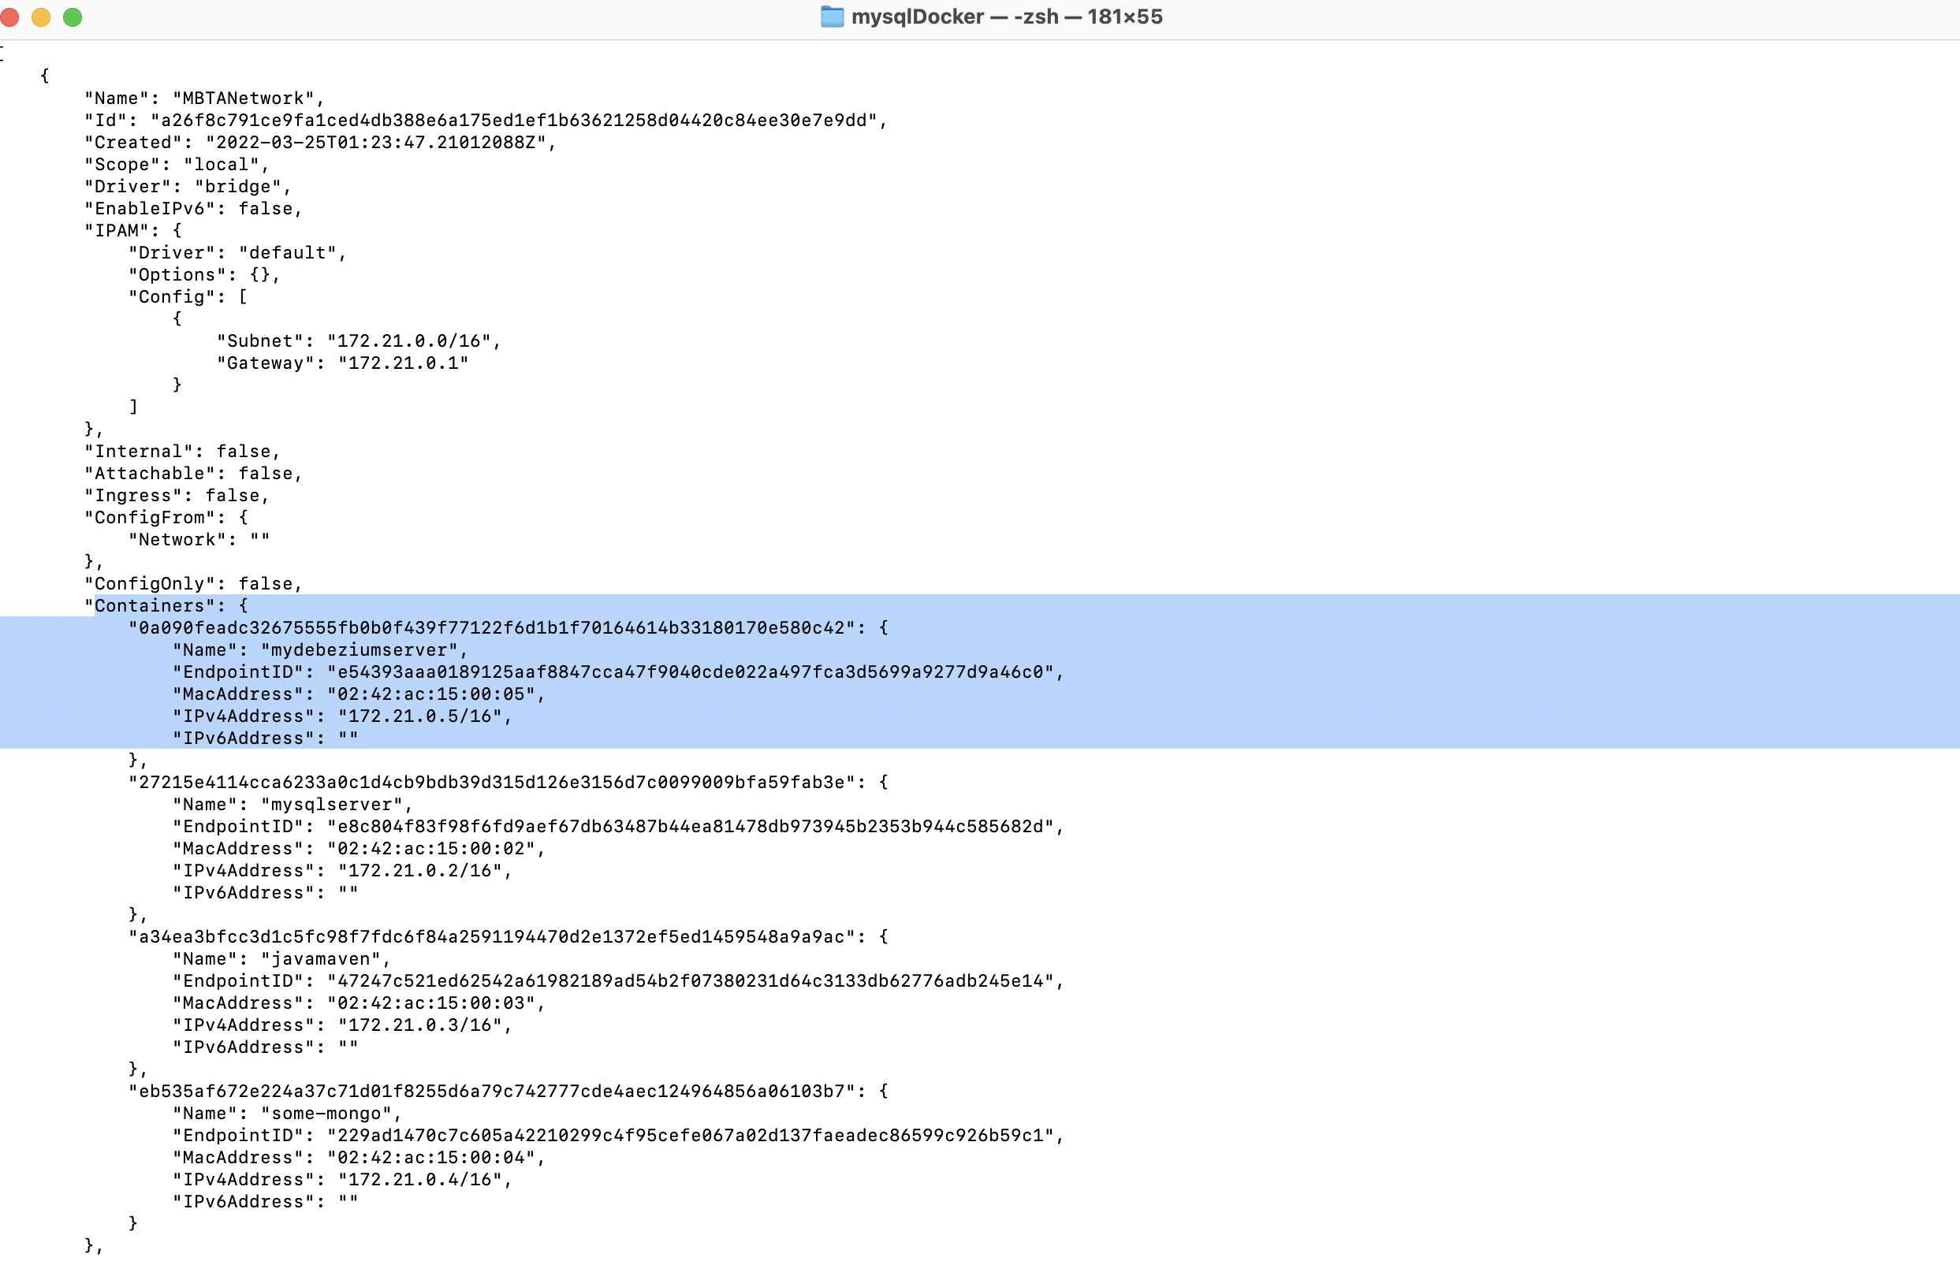

* + 1. Provide a screenshot to show that you have successfully installed the nano text editor in your shell.

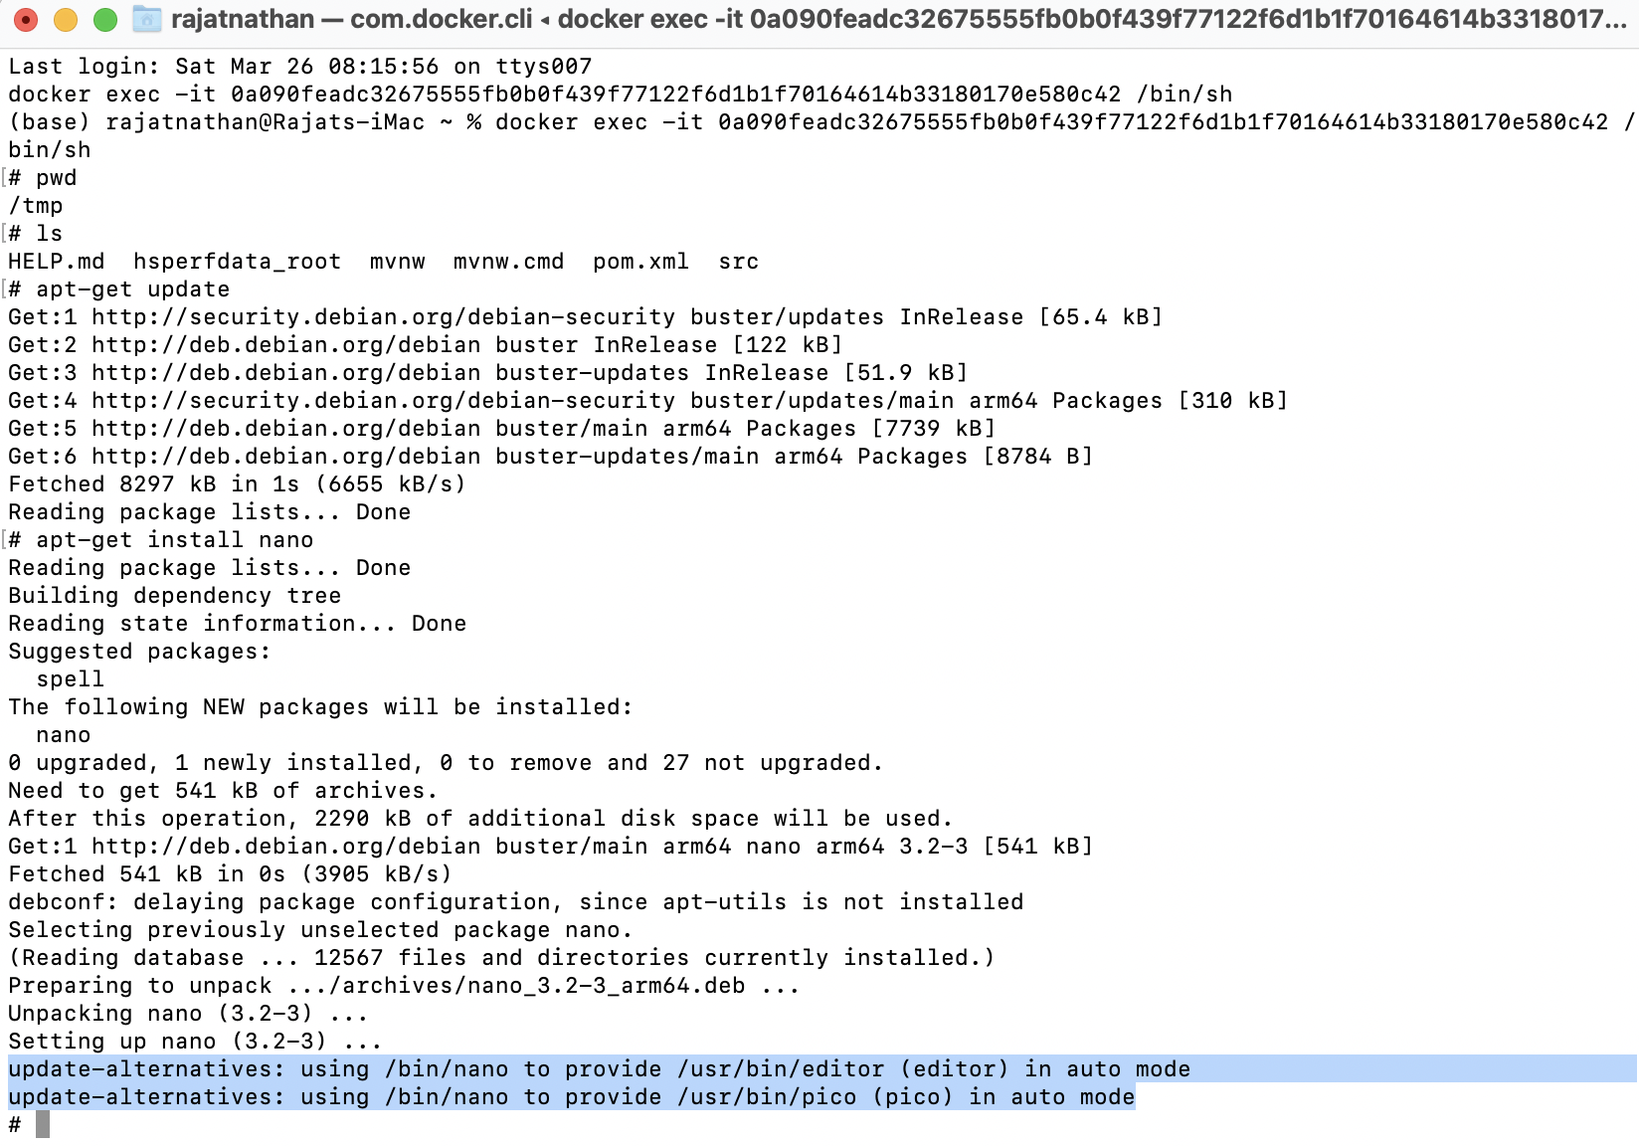

* + 1. Provide a screenshot to show that you have successfully modified the MongoDB.java class.

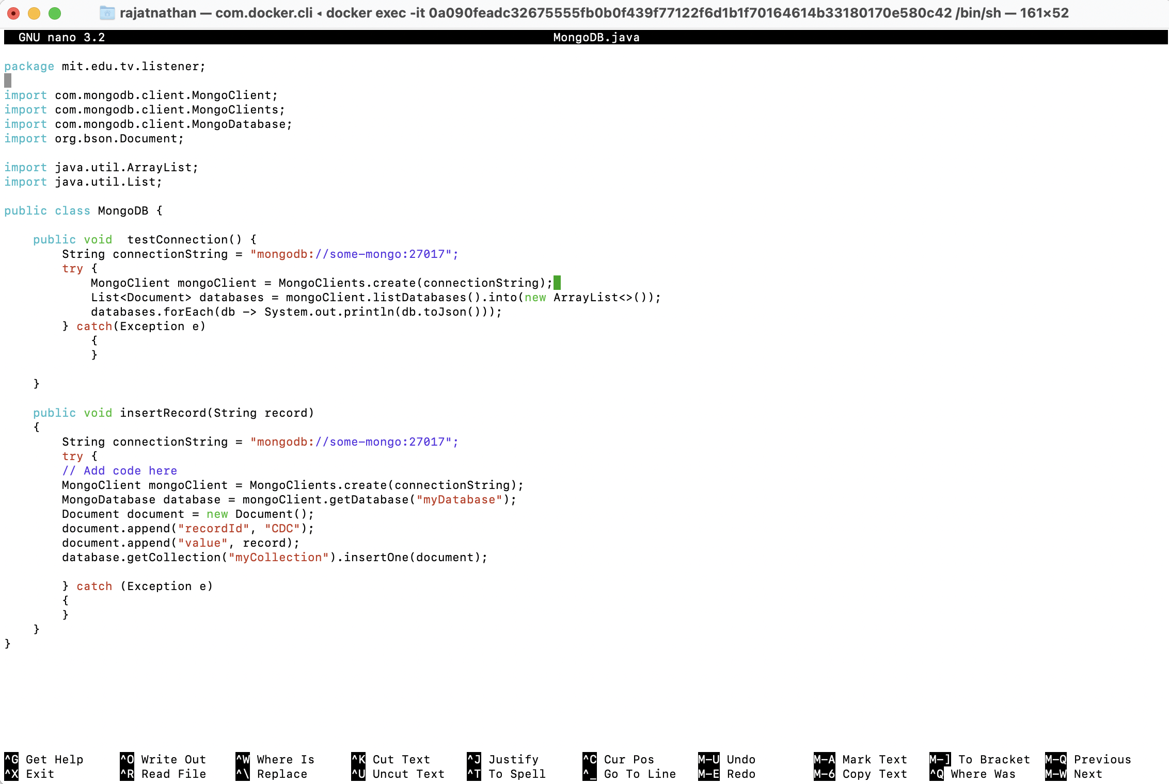

* + 1. Provide a screenshot to show that you have successfully modified the handleChangeEvent method.

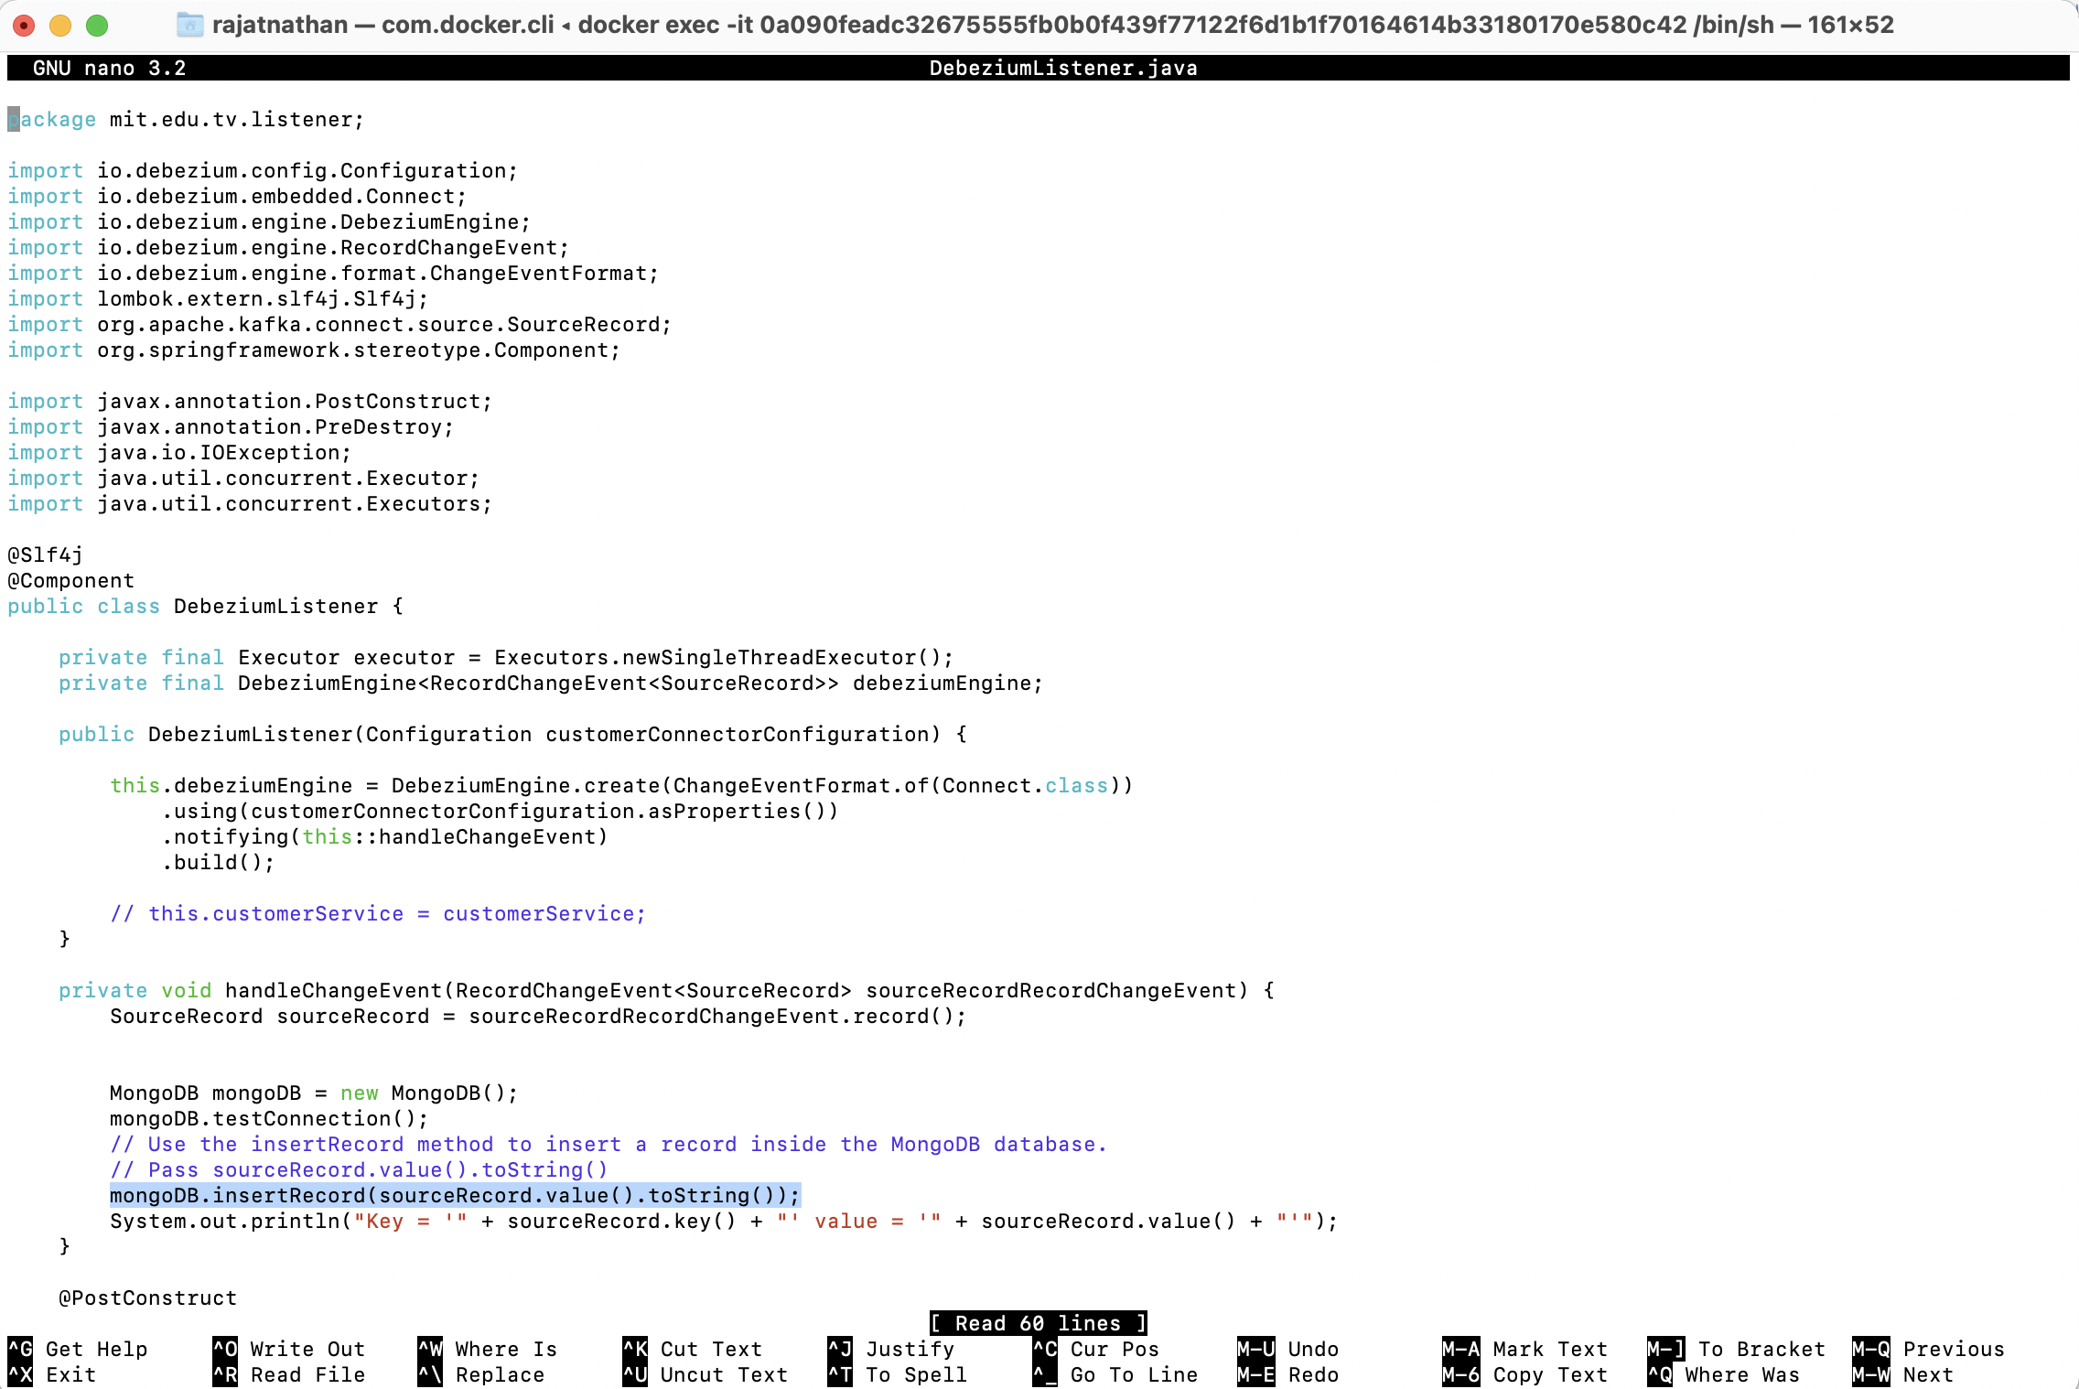

* + 1. Provide a screenshot to show that you have successfully run the Maven SpringBoot application.

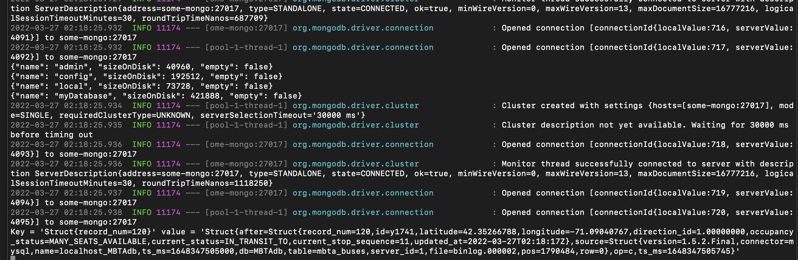

1. * 1. Provide a screenshot of your Docker desktop to show the javamaven container running.

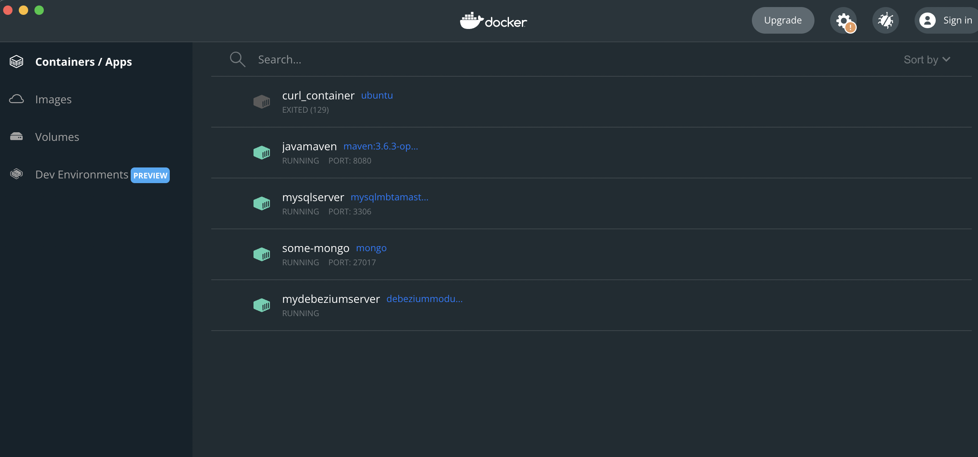

* + 1. Provide a screenshot to show that you successfully navigated to the directory and listed the files.

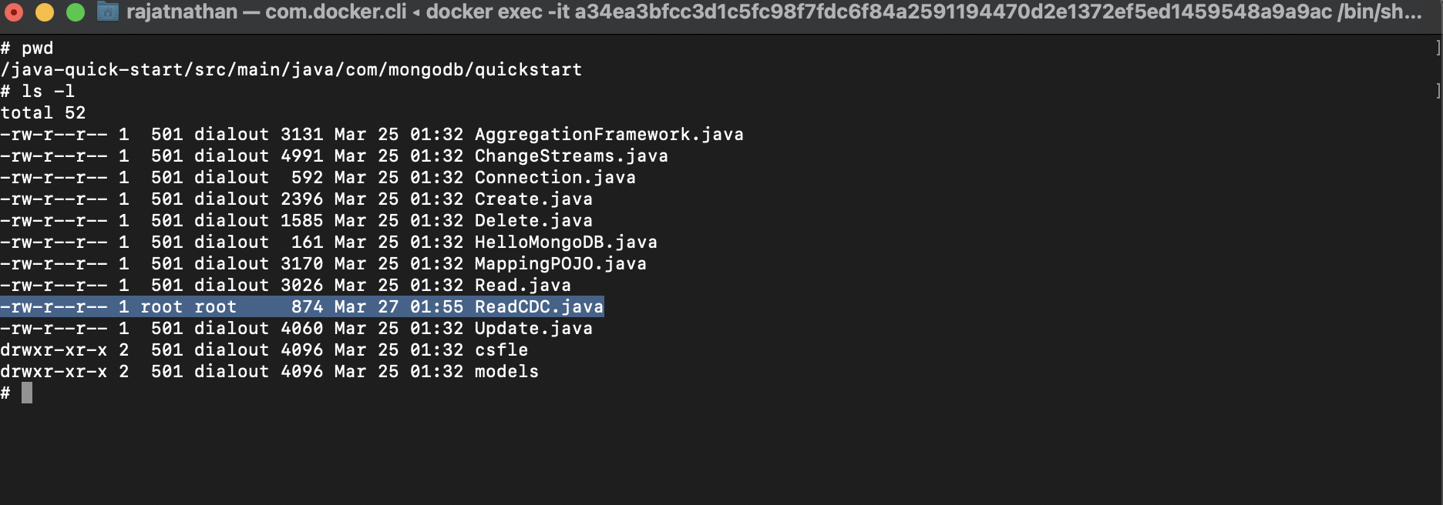

* + 1. Provide a screenshot to show that you successfully created the ReadCDC.java file and copied the code.

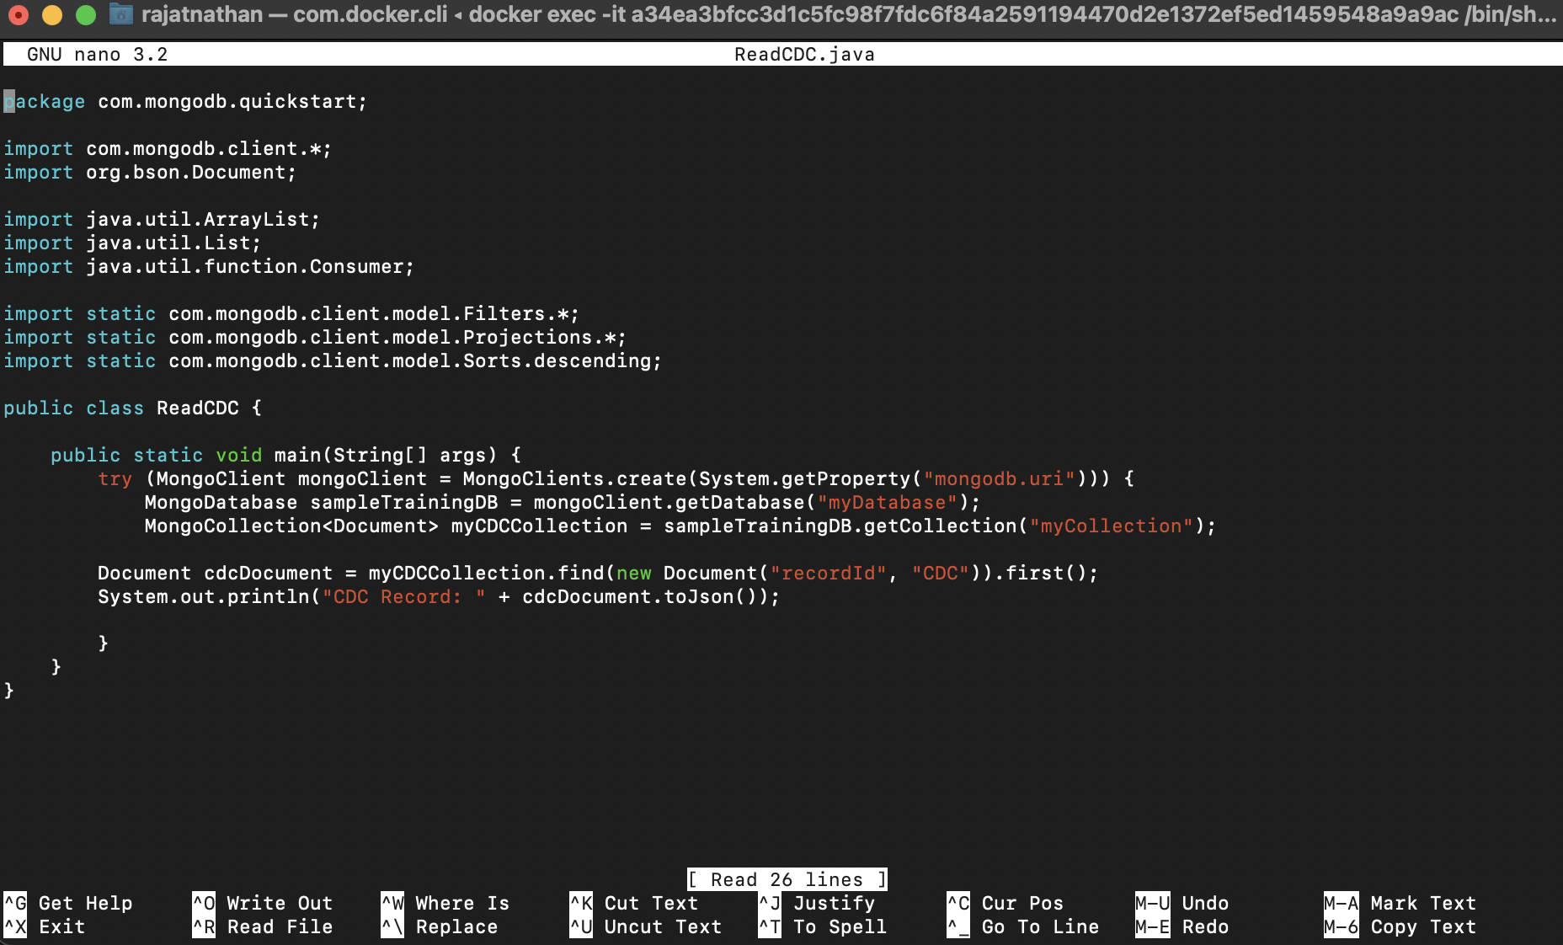

* + 1. Provide a screenshot to show the results of the bash command to execute the ReadCDC.java class.

